



Business Requirement Document
Supply Chain Management
NWS Commercial Evaluation Approval
DOCUMENT FOR

Table of Contents:
Table of Contents: 1
1. Introduction 2
1.1 Business Need 2
1.2 Expected Business Outcomes 2
1.3 Project Scope Summary 2
2. Business Requirement Details 3
2.1 Requirement Description 3
Header Fields 3
Custom Fields 4
2.2 Functional Tabs 4
2.3 Workflow & Approval Process 5
3. System Integration 5
4. Process Flow 6
5. Assumptions & Constraints 6
6. Risks & Mitigation 7
7. Report 7
8. Application Prototype 8
9. Acceptance Form 9
10. Open and Close Issues 9
10.1 Open Issues 9
10.2 Closed Issues 10

1. Introduction

1.1 Business Need
Currently, the Commercial Evaluation Approval process EBS manually handled through emails and offline meeting minutes. To streamline this and ensure system-driven governance, a custom Commercial Evaluation Approval application will be developed using Oracle Visual Builder Cloud Service (VBCS), integrated with Oracle Fusion Sourcing. This custom solution allows Contract Holders and Buyers to initiate, track, and complete Commercial Evaluation approvals directly from the Oracle Fusion Negotiation page once Commercial Scoring is completed.

1.2 Expected Business Outcomes
- Automated Commercial Evaluation Approval workflow within Oracle Fusion.
- Enhanced transparency and governance in the commercial approval process.
- Digital record with full audit trail for actions and attachments.
- Seamless integration with Oracle Fusion Negotiation DFFs.
- PDF-based approval documentation using BI Publisher.

1.3 Project Scope Summary
The scope covers the design and deployment of a custom VBCS-based Commercial Evaluation Approval page integrated with Oracle Fusion. The application enables Contract Holders to initiate approvals via a 'Commercial Evaluation Approval' button, fetch negotiation details, support workflow routing to committee members via PCS, generate PDF reports, and sync approval status with Fusion Negotiation DFF fields.

2. Business Requirement Details

2.1 Requirement Description
When the tender’s commercial scoring is completed, the Contract Holder clicks the 'Commercial Evaluation Approval' button on the Oracle Fusion Negotiation View Page. This button is enabled only when the tender status is 'Evaluation Completed: Commercial.' The user lands on the Commercial Evaluation Approval Page, which contains pre-populated header fields and custom input sections.

Header Fields
Field Name | Description | Behavior
Tender Number | Unique tender reference number from Fusion Negotiation | Pre-populated
Tender Title | Title of the tender | Pre-populated
Tender Publish Date | Date when the tender was published | Pre-populated
Tender Close Date | Tender submission closing date | Pre-populated
Commercial Unlock Date | Date of commercial bid opening | Pre-populated
Commercial Scoring Completion Date | Date of commercial evaluation completion | Pre-populated
Tender Owner | Person responsible for the tender | Pre-populated

Custom Fields
Field Name | Description | Type / Length
Objective | Purpose of the evaluation approval | Text (1000 chars)
Background | Detailed background information | Text (Unlimited)
SCM Comment | SCM team comments | Text (1000 chars)
Division’s Recommendation | Division’s recommendation | Text (1000 chars)
Committee Decision | Final decision from the committee | Text (1000 chars)
Attachments | Related files/documents | Upload field
Approval Status | Status of approval (Pending, Approved, Rejected, Withdrawn) | System Generated

2.2 Functional Tabs
- Header Details – Displays tender and custom information.
- SCM & Division Comments – Capture SCM and division inputs.
- Committee Decision – Committee’s final conclusion entry.
- Attachments – Upload and view relevant files.
- Approval History – Workflow tracking of actions and timestamps.

2.3 Workflow & Approval Process
- Contract Holder completes commercial scoring.
- Commercial Evaluation Approval' button becomes active.
- User navigates to the Commercial Evaluation Approval custom VBCS page.
- Inputs Objective, Background, SCM Comment, Recommendation, Decision, and Attachments.
- Submits to Committee members for review.
- Committee users Approve / Reject / Withdraw.
- Approval status updates are reflected in both VBCS and Fusion Negotiation DFF.
- PDF output generated for records.

3. System Integration
System | Module | Integration Point | Description
Oracle Fusion | Sourcing | Negotiation Page | Fetch and update negotiation details and DFF fields
VBCS | Custom Page | Commercial Evaluation Page | Interface for entry, submission, and PDF generation
PCS | Workflow | Approval Routing | Approval routing and status synchronization
BI Publisher | Reports | PDF Output | Generate Commercial Evaluation PDF document

4. Process Flow
- Buyer completes commercial scoring.
- 'Commercial Evaluation Approval' button becomes active.
- User navigates to the Commercial Evaluation Approval custom VBCS page.
- Inputs Objective, Background, SCM Comment, Recommendation, Decision, and Attachments.
- Submits to Committee members for review.
- Committee users Approve / Reject / Withdraw.
- Approval status updates are reflected in both VBCS and Fusion Negotiation DFF.
- PDF output generated for records.

5. Assumptions & Constraints
- Tender must be in status 'Evaluation Completed: Commercial.'
- Approvers (Committee) are preconfigured in PCS.
- REST API availability is required for integration with Fusion.
- User roles and privileges are managed through Oracle Identity Services.

6. Risks & Mitigation
Risk | Impact | Mitigation
API downtime | Delay in data fetching | Retry and alert mechanisms
Workflow routing delays | Approval bottleneck | Enable escalation rules
PDF generation failure | Incomplete documentation | Maintain backup BI templates

7. Report
The system generates a Commercial Evaluation Approval PDF showing header, comments, and decisions. The PDF report includes Tender Details, Evaluation Comments, and Approval Workflow History.

8. Application Prototype
Prototype includes Header, Comments, Decision, and Workflow History Tabs. The layout supports pre-populated fields, user inputs, and PDF generation.
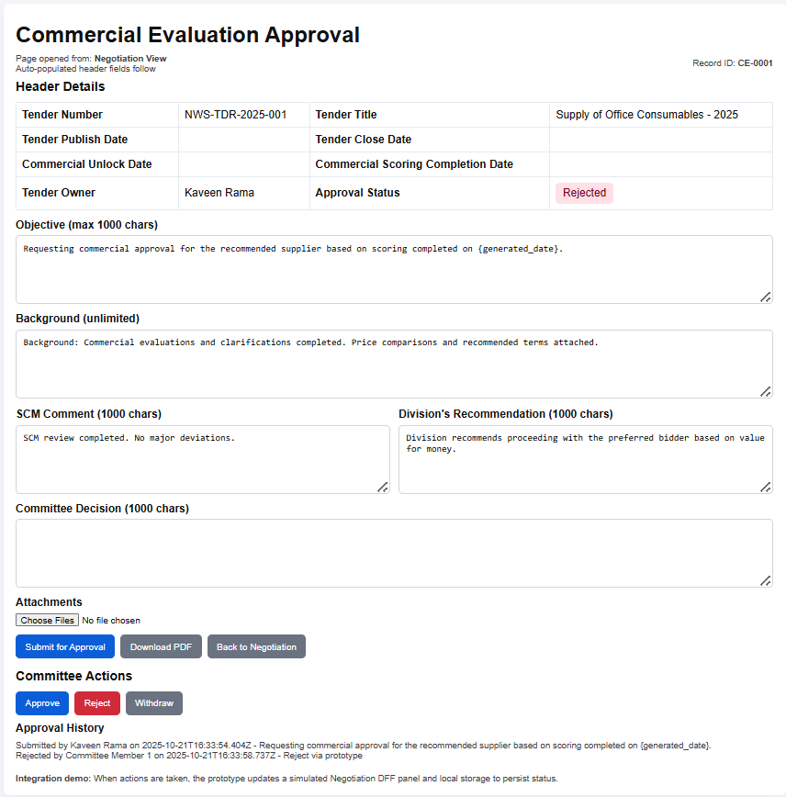

9. Acceptance Form
Project Name: | NWS Oracle Fusion Implementation
Document Name | NWS Commercial Evaluation Approval
Company Name: | 4i Apps Solutions
Name of Management: | Nama Water Services
Approved By (System Owner):
Designation:

10. Open and Close Issues

10.1 Open Issues
S. No | Issue | Resolution | Responsibility | Target Date | Impact Date
1 | Approval matrix finalization pending | To be confirmed with SCM team | NWS SCM Team
2

10.2 Closed Issues
S. No | Issue | Resolution | Responsibility | Target Date | Impact Date
1
2

